In local

Firstly run this command in console -

1. php artisan migrate

2. php artisan serve

3.php artisan fetch:articles (this command will fetch all the top articles from News API, New York Times ad media stack) and all the data reflect in article table

1.User Register API

POST request

API Endpoints - <http://127.0.0.1:8000/api/register>

Headers-

Accept - application/json

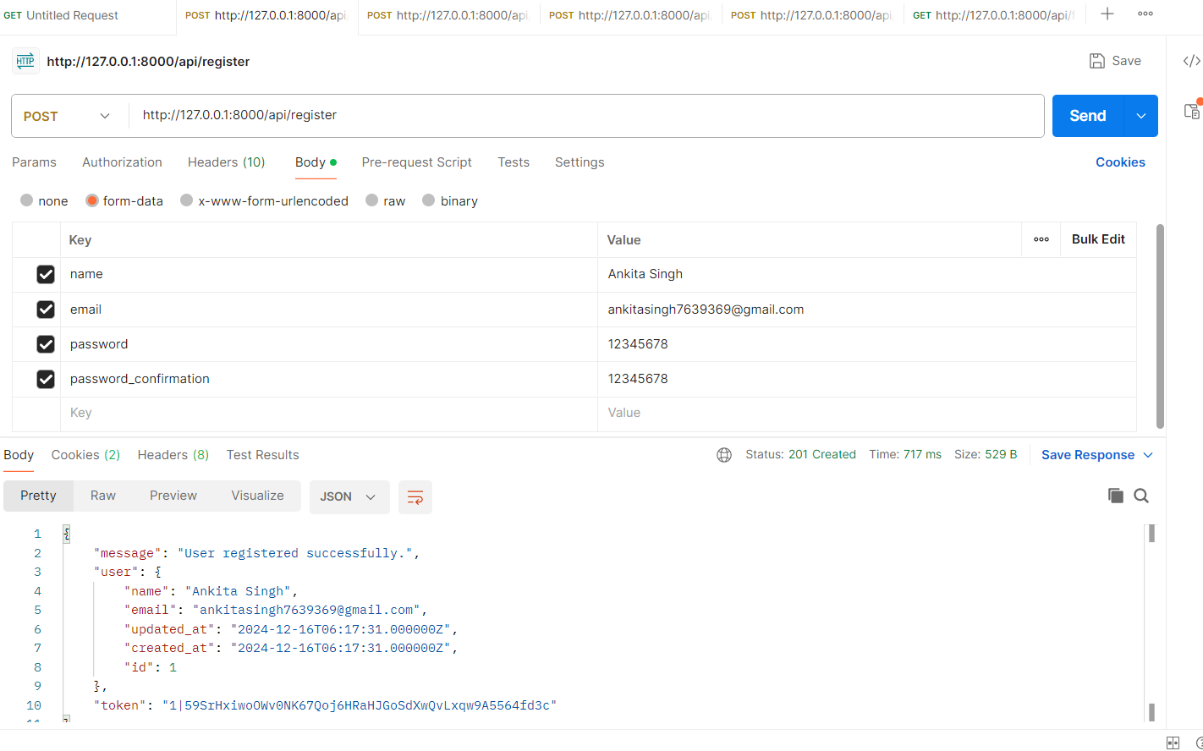

2.User Login API

POST request

API Endpoints - http://127.0.0.1:8000/api/login

Headers-

Accept - application/json

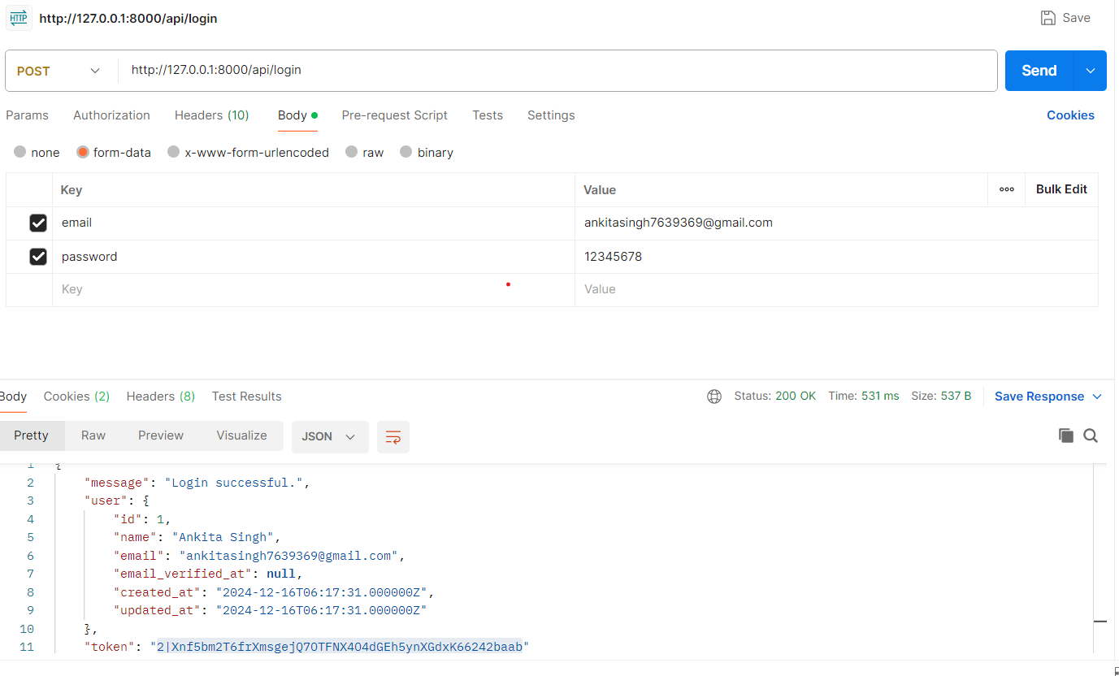

3.User Logout

Post Request

<http://127.0.0.1:8000/api/logout>

Headers-

Accept - application/json

Authorization- token you will provided when you login

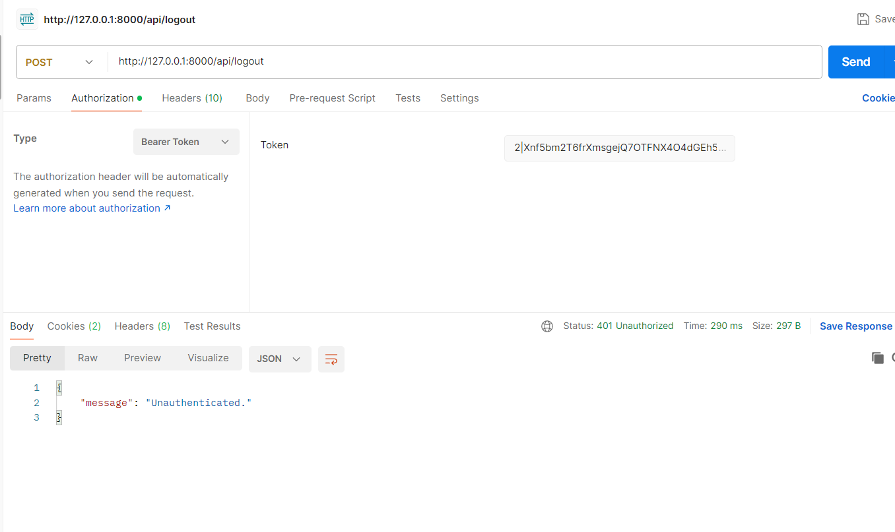

Note - this bearer token and token number will be added for article related endpoints and preference related endpoints and logout related endpoints

4.User Preferences Endpoints

Post Request

<http://127.0.0.1:8000/api/preferences>

Accept - application/json

Authorization- token you will provided when you login same as logout endpoints i have attached screenshot also

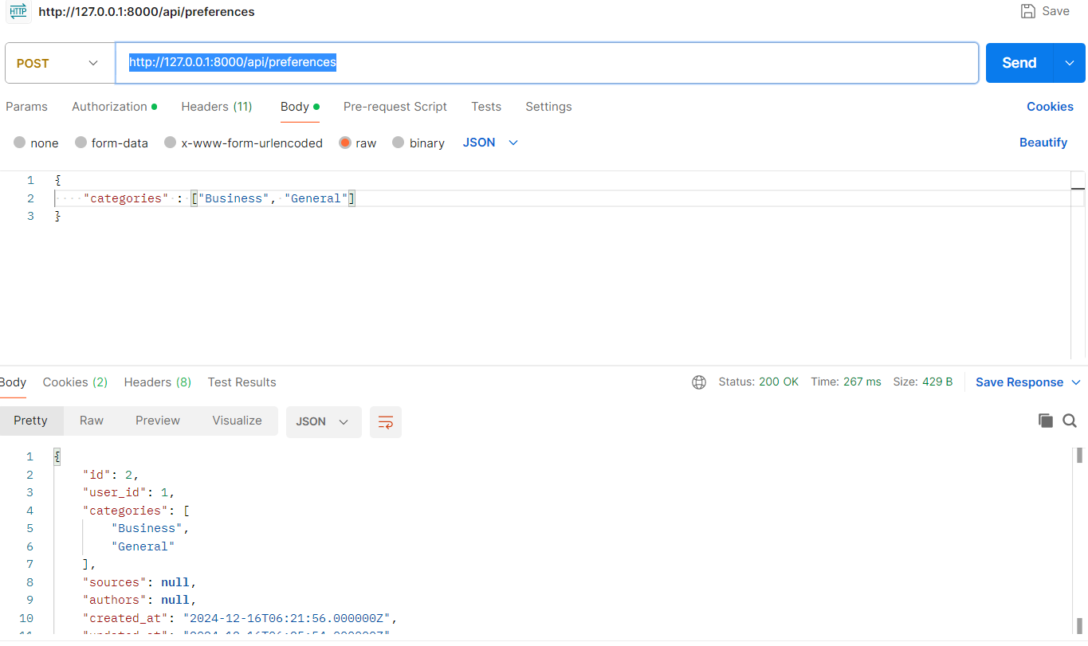

4.User Preferences Feed Endpoints

Get Request

http://127.0.0.1:8000/api/feed

Accept - application/json

Authorization- token you will provided when you login same as logout endpoints i have attached screenshot also

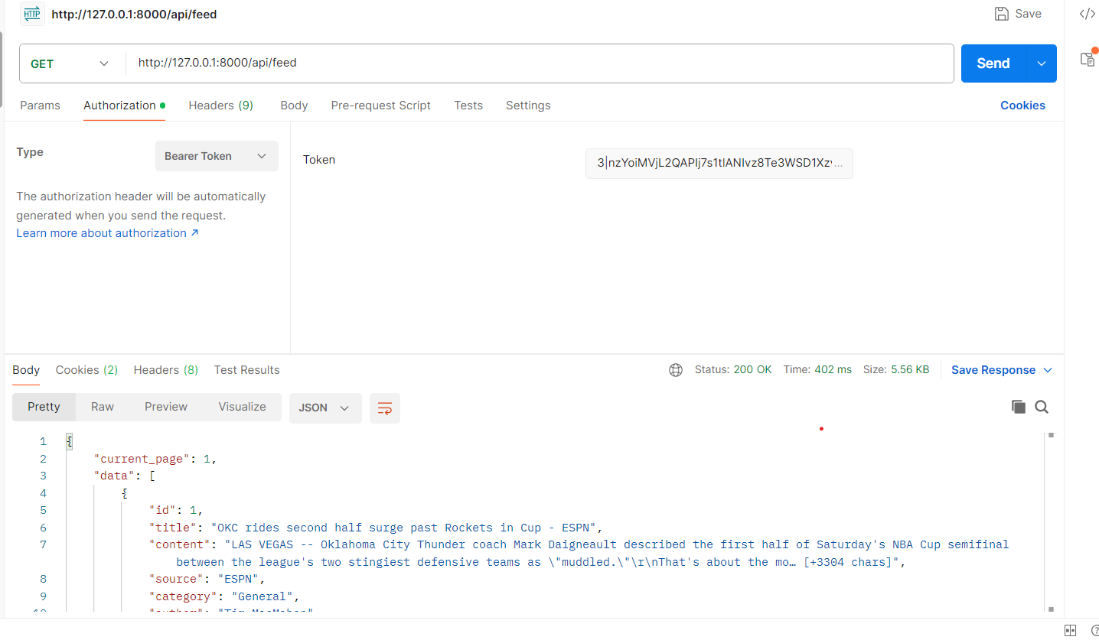

Articles Search -

Get Method

<http://127.0.0.1:8000/api/articles>

Accept - application/json

Authorization- token you will provided when you login same as logout endpoints i have attached screenshot also

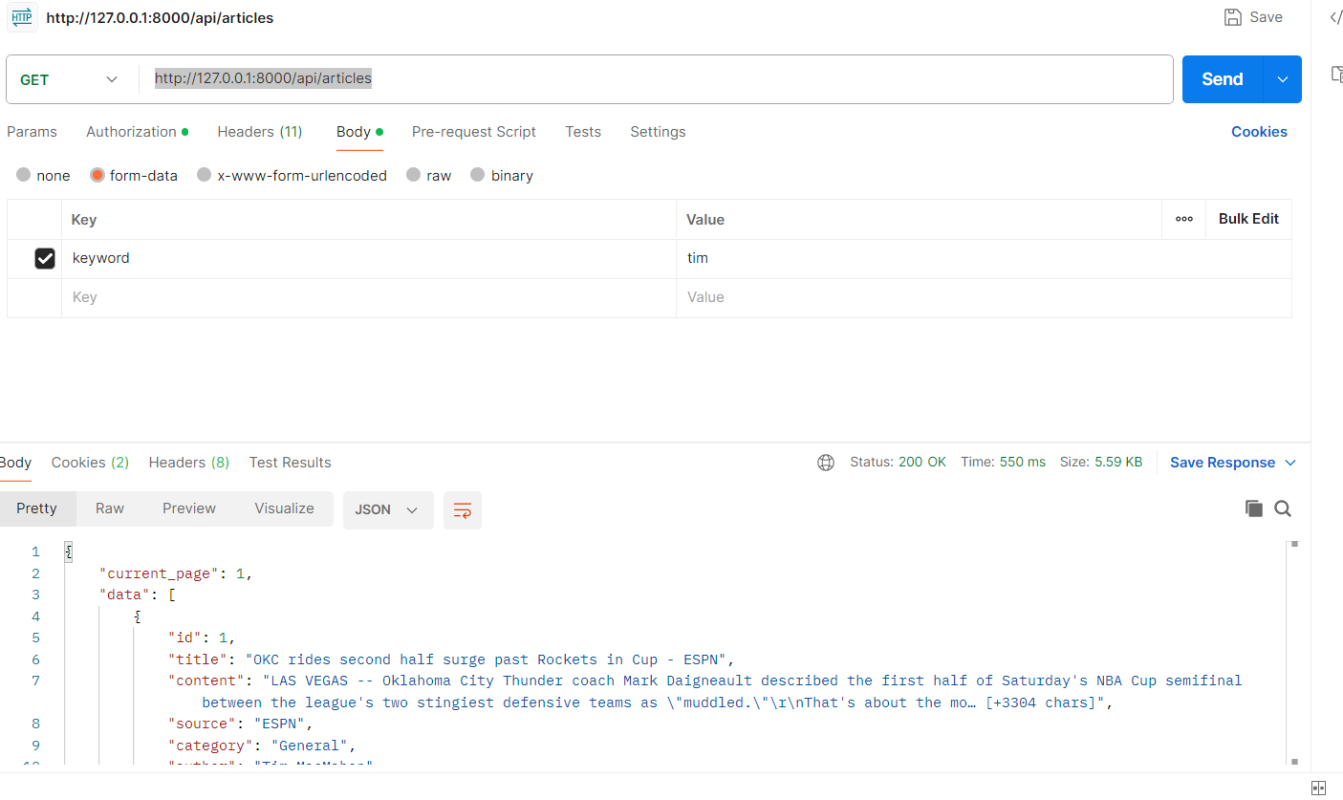

Reset Password EndPoints

Post Request -

<http://127.0.0.1:8000/api/password/reset>

Accept - application/json

Authorization- token you will provided when you login same as logout endpoints i have attached screenshot also